Raw Images of Capstone Project

– paper imprint  
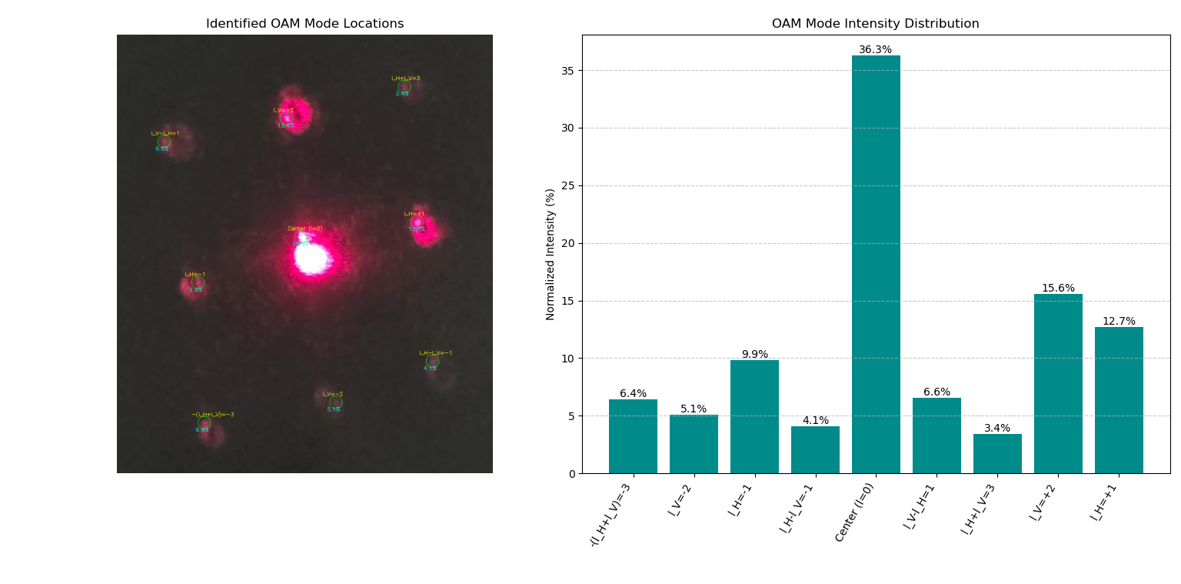

50um superimposed gratings – paper imprint

camera

Passed through annular of 80um on camera

S=2

S=1

S = -1

S = -2

Annular grating while tuning the right radius – paper

annular grating output after tuning for l = 2

Using 100um superimposed fork as grating 1 and 50um superimposed fork as grating 2 only 1 650nm laser ON despiraling the beam  
l = +1 passed through grating 2

l=-1 passed through grating 2

160um grating 1 l = +2 passed through grating 2

Multiplexing after 50um superimposed fork gratings

**S = -1**

**S = 0**

**S = +1 & -1**

**S = 0, 2**

**S = +1**

**S = +2**

**S = +1, -1**

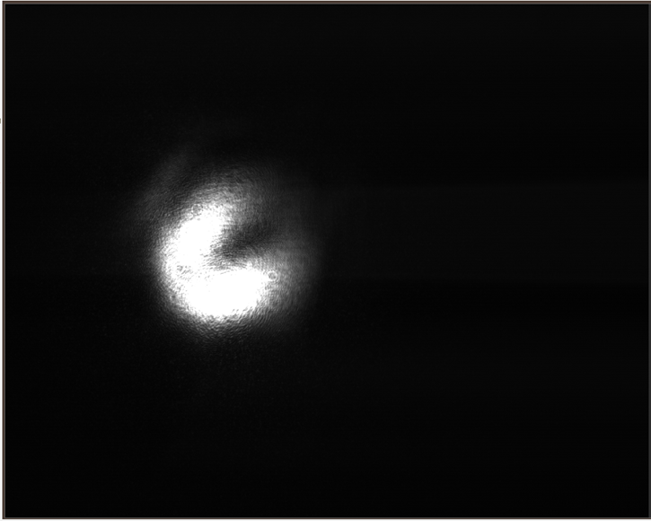

**s = +1, -1**

S = +1, -1 with petals

Demultiplexing

S = +1 , -1 can’t confirm because 0th order looks too bright can be gaussian the grating 1 was 50um, not sure about grating 2 must be 50um

Demultiplexing using 160um gratings – l =+2-1 Grating1 and Grating2 = 160um used 4 Neutral density filters 1/32 1/16 1/8 1/4  
